**First visualization**

**Headline: Marrying Age: This is when Chinese get married.**

**Version one: Multiple lines with annotations**

**Part 1: Getting Married Later**

**Data: B0504a.xls**

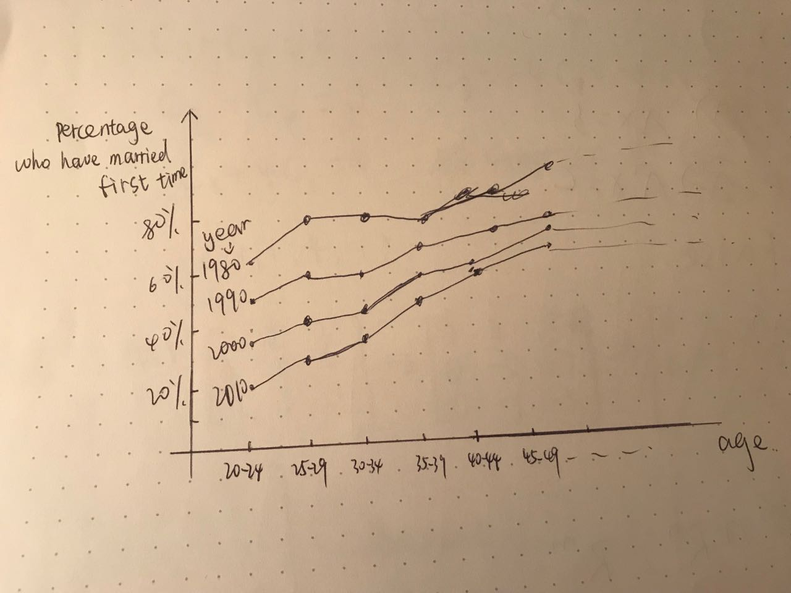

**Part 2: Seven year itch: When do people get married and divorced?**

**Data: B0503a.xsl**

The median marrying age for men is ? and median divorce age is ?

For women: marrying age and divorce age

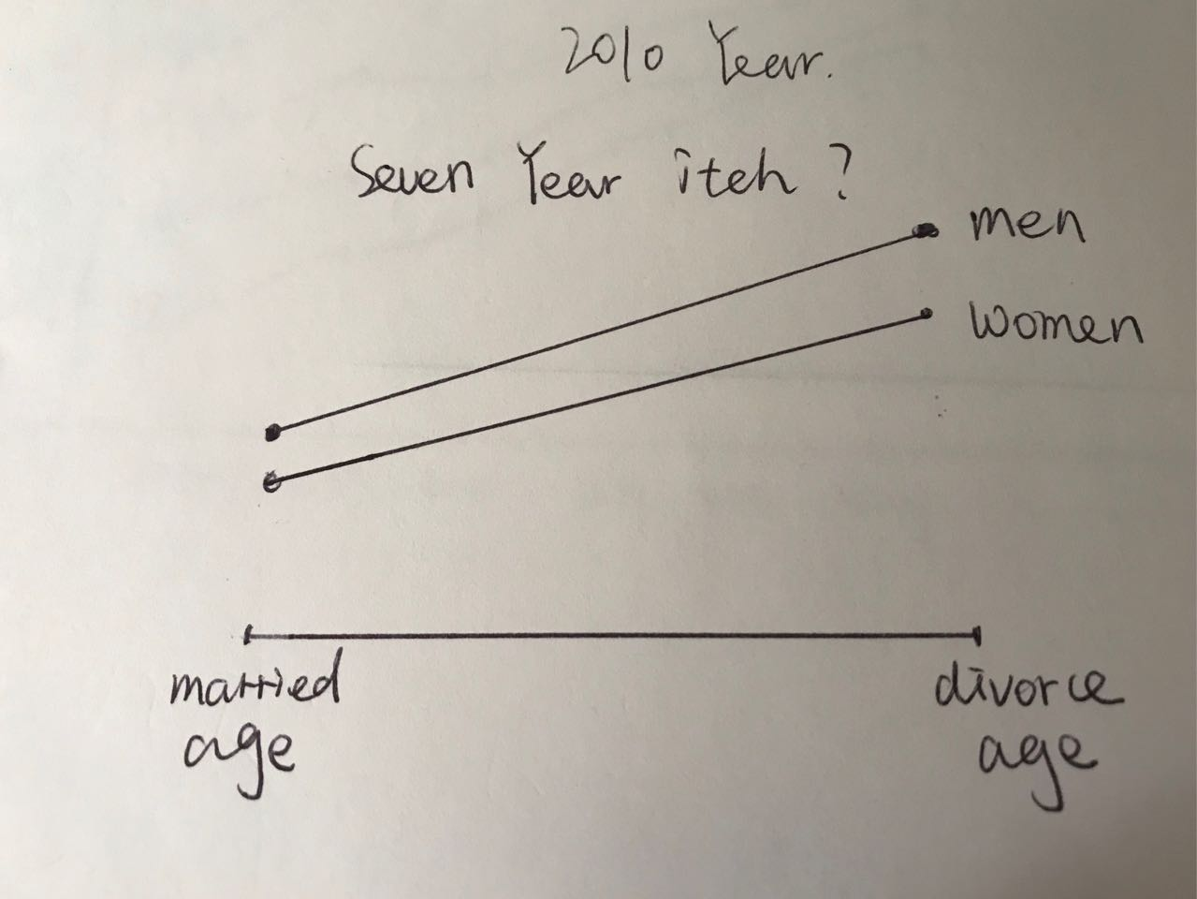

**Version two: Small multiples**

**Part 1:**

hover over an age group if the age/circle/line for that group lit up. (interactive)

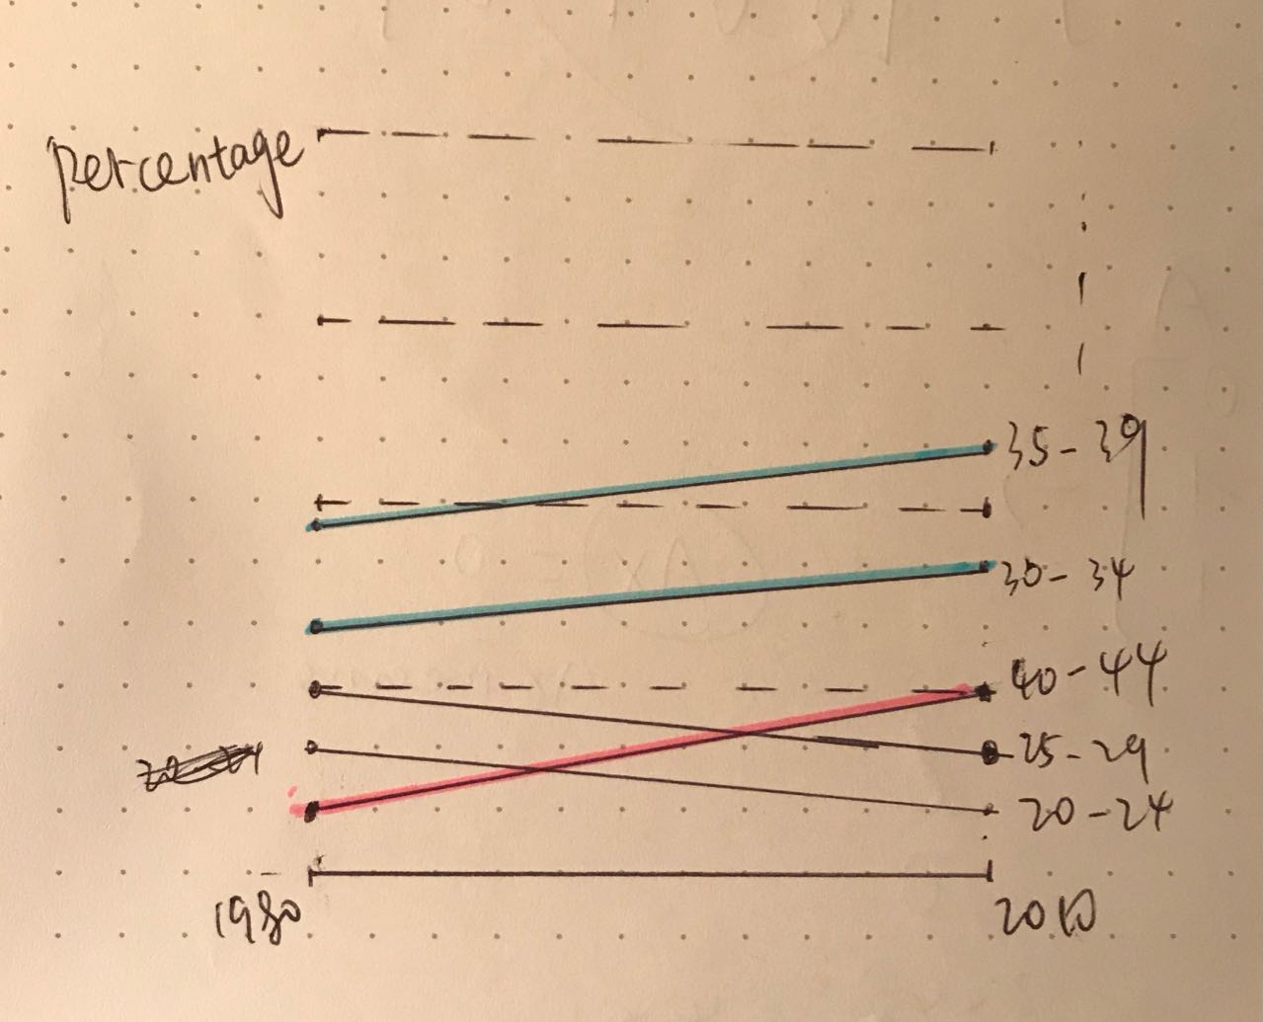

xPositionScale(d.year)

yPositionScale(d.percentage)

**Part 2:**



xPositionScale(d.age)

yPositionScale(d.percentage)

For the first visualization, I think the second version is better than the first. The second one gives the changed marrying age information more directly.

**Second visualization**

**Headline: Marital status in Mainland**

**Data: B0501a.xls**

**Version one: Small multiples**

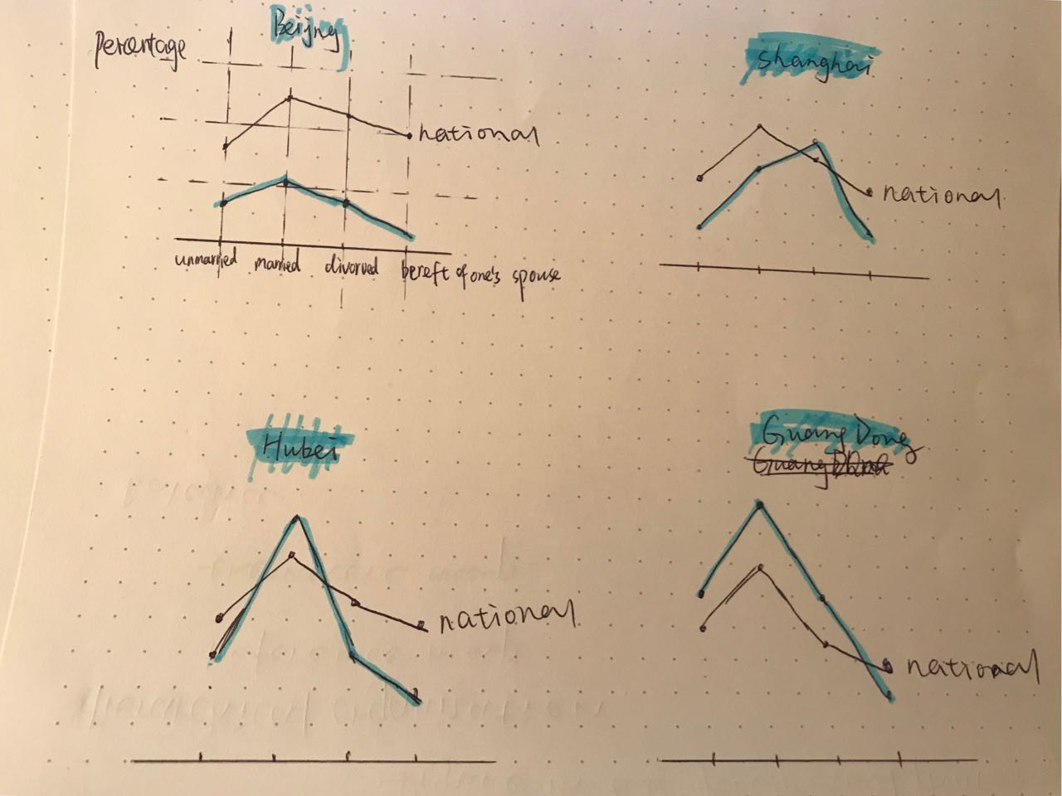

var xAxis = d3.axisBottom(xPositionScale).tickValues(["unmarried", "married", "divorced", "bereft of spouse"])

var yAxis = d3.axisLeft(yPositionScale).tickValues([20, 40, 60, 80]).tickFormat(function(d) { return "%" ; })

**Version two: Bar chart (Sorting by frequency)**

**Where get most marriage or divorce?**

**The same as married, divorce.**

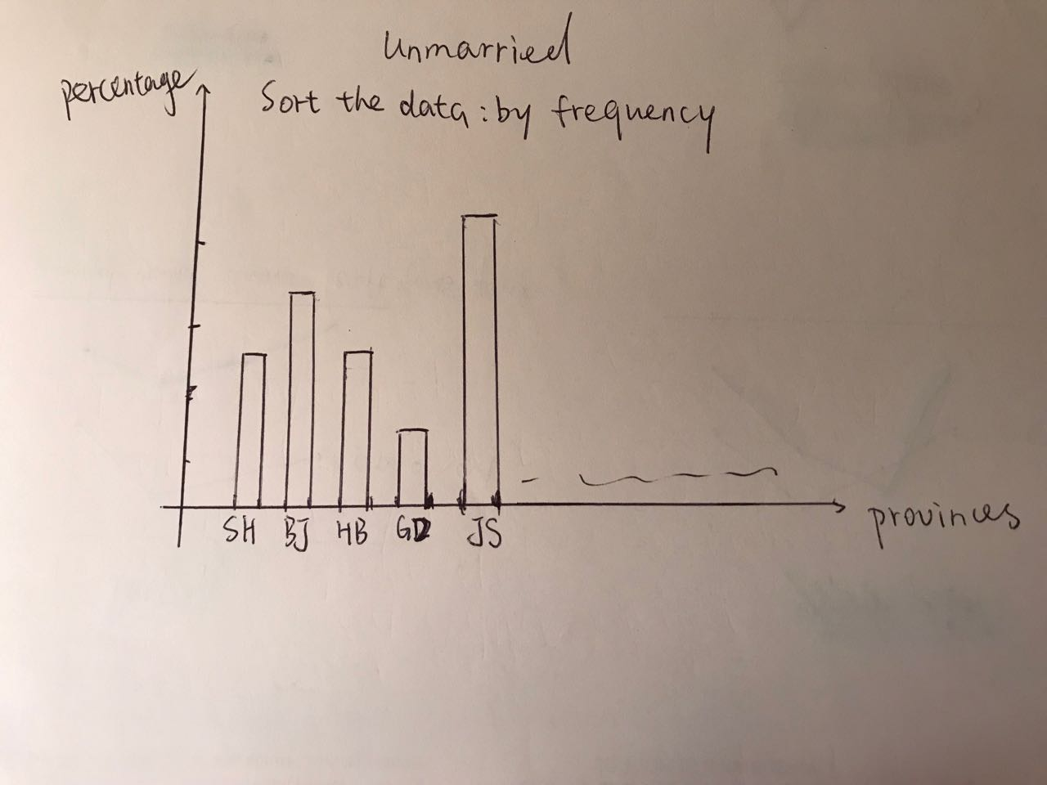

xPositionScale(d.province)

yPositionScale(d.percentage)

For the second visualization, two versions give different information. The first gives each province’s four marital statuses which compare with the national level. The second one makes information sortable by frequency.

Both visualizations need new data frame which means adding or deleting columns and rows, and also need to transpose, rename the axis etc.

age,percentage,year,gender

20-24,53.94,1980,female

20-24,56.56,2010,female

25-29,37.57,1980,female

25-29,42.55,2010,female

20-24,46.05,1980,male

20-24,43.44,2010,male

25-29,62.42,1980,male

25-29,57.45,2010,male